**Pretty Mary’s**

**Lunchtime Wraps**  
Served Mon-Sat 12-4pm

Sizzling Steak & Onion

Tossed in Pepper Sauce £9.50

Hot & Spicy Crispy Chicken

shredded gem lettuce,

mozzarella cheese £8.50

Buffalo Chickpea, Rocket, Celery, Ranch Dressing £7.50

Add a Cup of Soup or a Scoop of Fries for £2

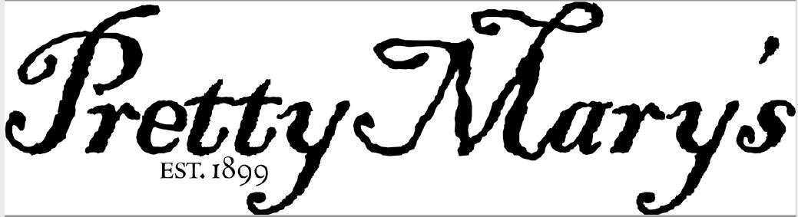

**LUNCHTIME WRAPS £7.00**Served Mon-Sat 12-4pm

- Sizzling Steak & Onion, Tossed in Pepper Sauce £9.50  
- Hot and Spicy Crispy Chicken, Shredded Gem Lettuce, Mozzarella Cheese £8.50  
- Buffalo Chickpea, Rocket, Celery, Ranch Dressing £7.50

Add a Cup of Soup or a Scoop of Fries for £2



**LUNCHTIME WRAPS £7.00**Served Mon-Sat 12-4pm

- Sizzling Steak & Onion, Tossed in Pepper Sauce £9.50  
- Hot and Spicy Crispy Chicken, Shredded Gem Lettuce, Mozzarella Cheese £8.50  
- Buffalo Chickpea, Rocket, Celery, Ranch Dressing £7.50

Add a Cup of Soup or a Scoop of Fries for £2



**LUNCHTIME WRAPS £7.00**Served Mon-Sat 12-4pm

- Sizzling Steak & Onion, Tossed in Pepper Sauce £9.50  
- Hot and Spicy Crispy Chicken, Shredded Gem Lettuce, Mozzarella Cheese £8.50  
- Buffalo Chickpea, Rocket, Celery, Ranch Dressing £7.50

Add a Cup of Soup or a Scoop of Fries for £2



**LUNCHTIME WRAPS £7.00**Served Mon-Sat 12-4pm

- Sizzling Steak & Onion, Tossed in Pepper Sauce £9.50  
- Hot and Spicy Crispy Chicken, Shredded Gem Lettuce, Mozzarella Cheese £8.50  
- Buffalo Chickpea, Rocket, Celery, Ranch Dressing £7.50

Add a Cup of Soup or a Scoop of Fries for £2



**LUNCHTIME WRAPS**Served Mon-Sat 12-4pm

- Sizzling Steak & Onion, Tossed in Pepper Sauce £9.50  
- Hot and Spicy Crispy Chicken, Shredded Gem Lettuce, Mozzarella Cheese £8.50  
- Buffalo Chickpea, Rocket, Celery, Ranch Dressing £7.50

Add a Cup of Soup or a Scoop of Fries for £2